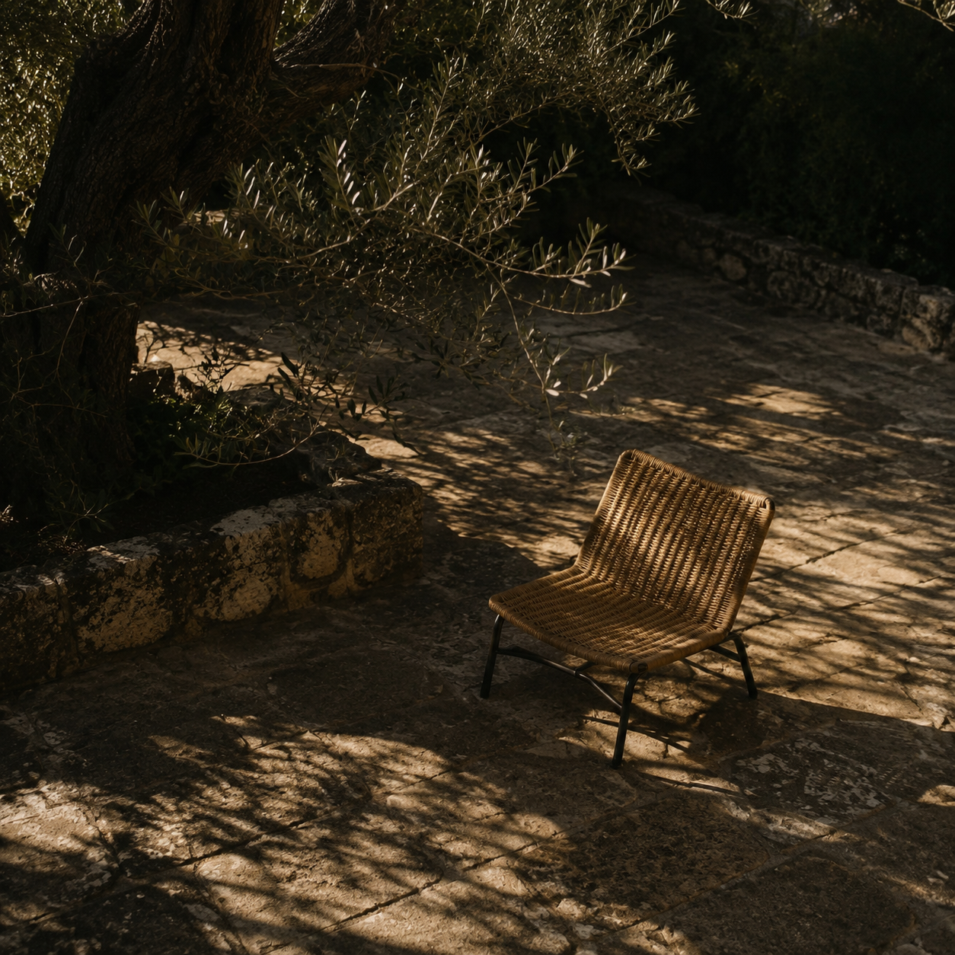

Uni Parent System Design
Browser Based Daily Planning MVP |  | Prepared for project collaborators  September 2026

Contents
Executive summary 2
Architecture and data flow 3
Verification 4
Appendix 5

Executive summary
Uni Parent is a working browser application that turns a student profile and repeating commitments into a balanced daily agenda. The first version uses transparent scheduling rules, stores data only in the current browser, and requires no account, server, API key, or package download.
The implemented MVP protects fixed commitments, places study and career actions near the student's preferred focus period, reserves wellbeing and leisure time, and reports work that cannot fit. Nine automated planner tests and live desktop and mobile browser checks passed on 4 September 2026.

At a glance
- The application is a responsive three-view site for Profile, Schedule, and Today.
- A deterministic planner produces repeatable, non-overlapping blocks and keeps fixed commitments unchanged.
- Local browser storage preserves profiles, schedules, generated plans, and completion state without transmitting personal data.

Product requirements
A student can choose an age band, major area, career track, career goal, wake and sleep times, preferred focus period, and leisure target. The student can add repeating class, work, and responsibility blocks and generate a plan for any selected date.
The MVP excludes authentication, cloud storage, calendar synchronization, notifications, overnight schedules, and live AI generation. Recommendations are planning suggestions rather than medical, academic, or professional guarantees.

Architecture and data flow
The system separates interaction, scheduling rules, recommendation content, and persistence. This keeps the planner independently testable and allows a later service to improve explanations without controlling the schedule.

Component model
The interface layer reads forms and renders the timeline. The planner validates time ranges, subtracts fixed commitments, ranks open windows, and returns a DailyPlan. The catalog supplies career actions, study prompts, and wellbeing defaults. The storage layer serializes the complete app state to localStorage.

Plan generation flow
The engine validates the profile and same-day commitments, converts times to minutes, and calculates open windows between wake and sleep. It places one career action, one study block, one wellbeing block, and an age-adjusted leisure block. Remaining gaps become breaks or free time.
[Profile and schedule] -> [Planner engine] -> [Daily plan] -> [Browser storage]
Key rule. Fixed commitments are immutable. When an activity cannot fit, the planner lists it as unscheduled instead of creating an overlap or silently removing it.

Data model and public interfaces
The public domain function is generateDailyPlan(profile, commitments, date), which returns a DailyPlan. The reserved async adapter enhancePlanExplanation(plan, profile) currently returns the plan unchanged and provides a safe phase-two extension point.
Type | Purpose | Main fields
StudentProfile | Student context and editable defaults | ageBand, majorArea, careerTrack, wakeTime, sleepTime, focusPreference, leisureTarget
Commitment | One repeating fixed block | id, weekday, start, end, title, type
PlanBlock | One fixed or generated agenda item | startMinutes, endMinutes, category, title, reason, fixed, completed
DailyPlan | The ordered output and exceptions | date, blocks, careerAction, warnings, unscheduled

Verification
The verification pass covered pure scheduling behavior and the running browser interface. The build used Node 24.18.0 with no third-party application dependencies.
- Automated planner tests. All nine Node tests passed, including time parsing, free-window calculation, conflict rejection, deterministic generation, and fallback behavior.
- Schedule safety. Normal and overloaded fixtures preserved fixed blocks, kept generated work inside the waking day, and produced no overlaps.
- Browser behavior. The sample plan rendered correctly, overlap errors were announced, mobile width matched the viewport, and the browser console contained no errors or warnings.

Limitations and future work
The current planner assumes wake and sleep occur on the same calendar day. Weekly commitments are entered manually, career content comes from a small reviewed catalog, and all state belongs to one browser profile.
Phase two can add calendar import, weekly planning, accounts, cloud synchronization, notifications, and adaptive feedback. An optional AI service may improve explanations and suggest career tasks, but the deterministic planner should remain the source of truth for time placement.

Appendix

One hour implementation sequence
The build order kept the planner on the critical path and postponed documentation until behavior was verified. The table records the intended timebox and its acceptance signal.

Minutes | Work | Verification
0 to 10 | Static structure, styles, sample data | App opens without installation
10 to 25 | Profile and commitment forms | Invalid and overlapping times are rejected
25 to 40 | Planner and career catalog | Pure functions pass representative fixtures
40 to 50 | Timeline, completion, local storage | Plans regenerate and survive refresh
50 to 60 | Automated and browser checks, README | Tests pass and mobile width is clean

Repository map
- Interface. index.html and styles.css define the three-view responsive experience.
- Application. src/app.js connects forms, navigation, generated plans, completion controls, and storage.
- Domain. src/planner.js and src/catalog.js contain deterministic rules and recommendation content.
- Verification. tests/planner.test.js covers the planner, while README.md contains setup and manual acceptance steps.

Review checklist
- Run npm test and confirm that all nine planner tests pass.
- Run npm start and confirm that the sample plan appears without setup or an API key.
- Try an overlapping commitment and confirm that the form explains the conflict.
- Complete a plan item, refresh the page, and confirm that the saved state returns.

